Hao Ge (Harvey) Yang
903320189
Ashok K Goel
CS 7637- KBAI
September 21, 2017

Project 1 Reflection
The AI agent built in this project uses a strictly visual approach to solve the 2x2 Raven’s Progressive Matrices (RPM) problems. Although both the visual and verbal representations of the problems were provided for this project, I felt solving the problems verbally limited the knowledge of the agent to the shapes and vocabulary given in the problems and this would restrict the abilities of the agent as it progresses to solve more difficult problems. The visual approach, on the other hand, allows the agent to utilize shape agonistic methods and attempt novel approaches. In addition, the RPM problems are a set of visual problems to test intelligence, solving them visually allows the AI agent to draw ideas from how humans solve these problems and make inferences to human cognition.
The overall design of the agent uses the concepts of semantic networks for knowledge representation, as well as generate and test to examine the generated outputs of a transformation by the agent against the given solutions to the problems. In the starter code provided, the RavensProblem object already encapsulates the figures and images information of a problem into one object. Upon entering the main Solve method of the agent, the agent parses the images of the problem given and stores them in a dictionary data structure, where the key is the name of the image frame, such as ‘A’, ‘B’, ‘1’, etc., and the values are the Image objects opened by Pillow. This dictionary of key value pairs is then passed to another method which will traverse a list of transformation methods to solve the problem. Since this agent tackles 2x2 problems and uses the references frames ‘A’, ‘B’, and ‘C’ extensively, these three figures are further extracted out into separate variables for ease of use in passing to other transformation methods. This process is represented in Figure 1, where each arrow is a call to another method. 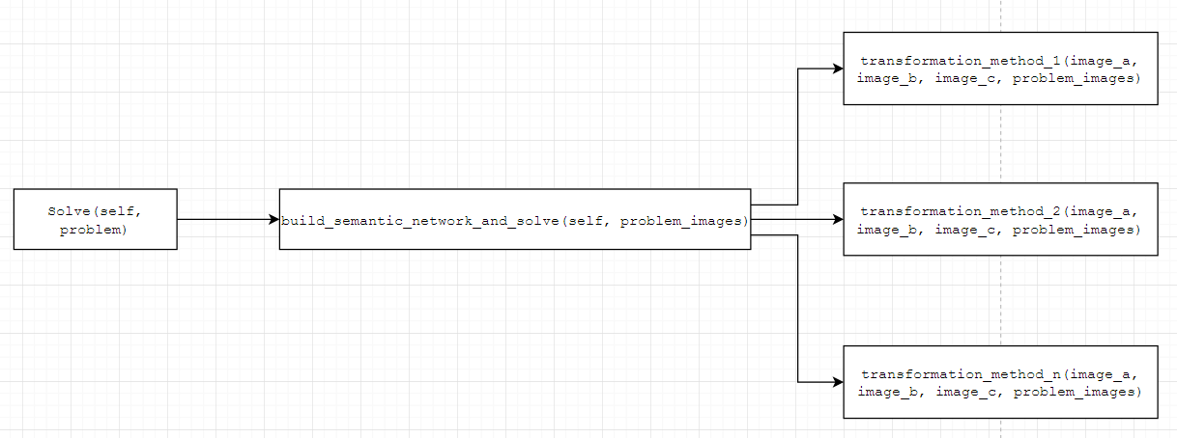
Figure 1. Design flow of the AI agent
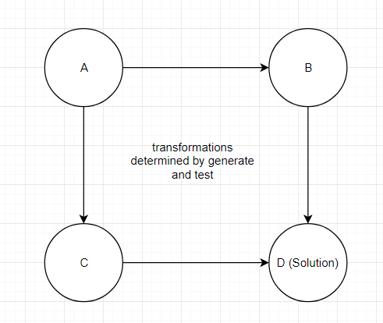
It’s interesting to note that the agent itself is shape agnostic. It does not have logic to discern and separate shapes in the individual images or store them in any data structures, there is also no explicit semantic net built to describe the relationships between the individual objects between shapes within an individual frame or with other frames. The nodes in this semantic network are simply the three reference images and the six solution images, which could also be interpreted as frames with the Image object itself as the filler. This representation is inspired by how we as humans look at these problems initially. Typically, as humans, we examine these images as a whole first, and dissect them into parts if necessary during the problem-solving stage, this is the approach the agent adopts as well, by storing the entire images in its knowledge representation. The transformations between the nodes are discerned in the next phase where the agent will attempt many pre-defined transformations to distinguish the relationships between the nodes.
Figure 2. Overall knowledge representation of the AI agent. Each node is an individual image.
Upon separating the images out and storing them in a dictionary, the agent will then attempt numerous transformations to distinguish the transformations between the frames and try to see if an answer is able to be retrieved from the solution choices. Unlike what was shown in the lectures, this agent does not explicitly try to distinguish all the transformations between the shapes and nodes in the semantic network building phase. Instead, the transformations are tested on the fly and generate and test will be used immediately within the transformation method to see if potential answers could be found by attempting the same transformations on the given list of answer choices. If a unique solution is found, the transformation is determined and the solution will be returned. This mimic the way humans think, typically, we will try a method for problem solving and see if we could solve the problem with that method, and move on to another method if it does not work. All the image transformation (non-pixel related) methods of the agent follow a similar design, the agent will attempt the transformation for frame A to generate an output image, this is compared to frame B to check if they are equal (horizontal comparison). If they are equal, then the agent will then use the transformed image of frame C and loop through the 6 answer choices and compare each one against this transformed image, and if they are equal, the choice will be added to a list of potential answers. This is because the images provided are not identical and have slight pixel differences, therefore a root mean square difference is used to make sure all potential answers are accounted for. If a unique solution is found, then the choice will be returned as the answer. If no answer is found, this process is repeated for frames A and C (vertical comparison), and if no unique solution is found again, the transformation will return -1 and move on to the next transformation method. The pixels comparison methods are very similar in logic, a ratio or difference is calculated for the reference frames, e.g.., the black pixel difference between frames A and C. Then, the transformation methods will walk through all the answer choices and calculate the difference between frames B and the choice, if the difference matches the difference between A and C to a certain degree, it will be accounted for as a potential answer, the unique answer or the answer closest to the reference ratio will be returned, similarly for A and B, with C as the reference to the solutions.
The way the transformations are ordered follows the same logic as the weighting scheme we saw in the lectures. These orders were generally decided by the amount of changes involved in the transformations. The identity transformation, for example, means that the two frames are identical, therefore it is preferred over a reflection transformation, etc. The agent mimics humans by attempting these problems at a high level first (image transformations), then more complicated and granular (pixel level) if the high-level transformations fail.
Sequence | Transformation | Description
1 | Unchanged (Identity) | No changes between the frames being compared
2 | Y-Axis Reflection | The first frame is reflected by its Y axis to get the second frame
3 | X-Axis Reflection | The first frame is reflected by its X axis to get the second frame
4 | Rotation | The first frame is rotated at angles to get the second frame (stop at that angle)
5 | Pixel Difference | The first and second frames differ by certain number of black pixels
6 | Pixel Ratio by Frame | The first and second frames differ in black pixel ratio (black pixels/total pixels)
7 | And | Superimpose the first frame onto the second frame to get the second frame

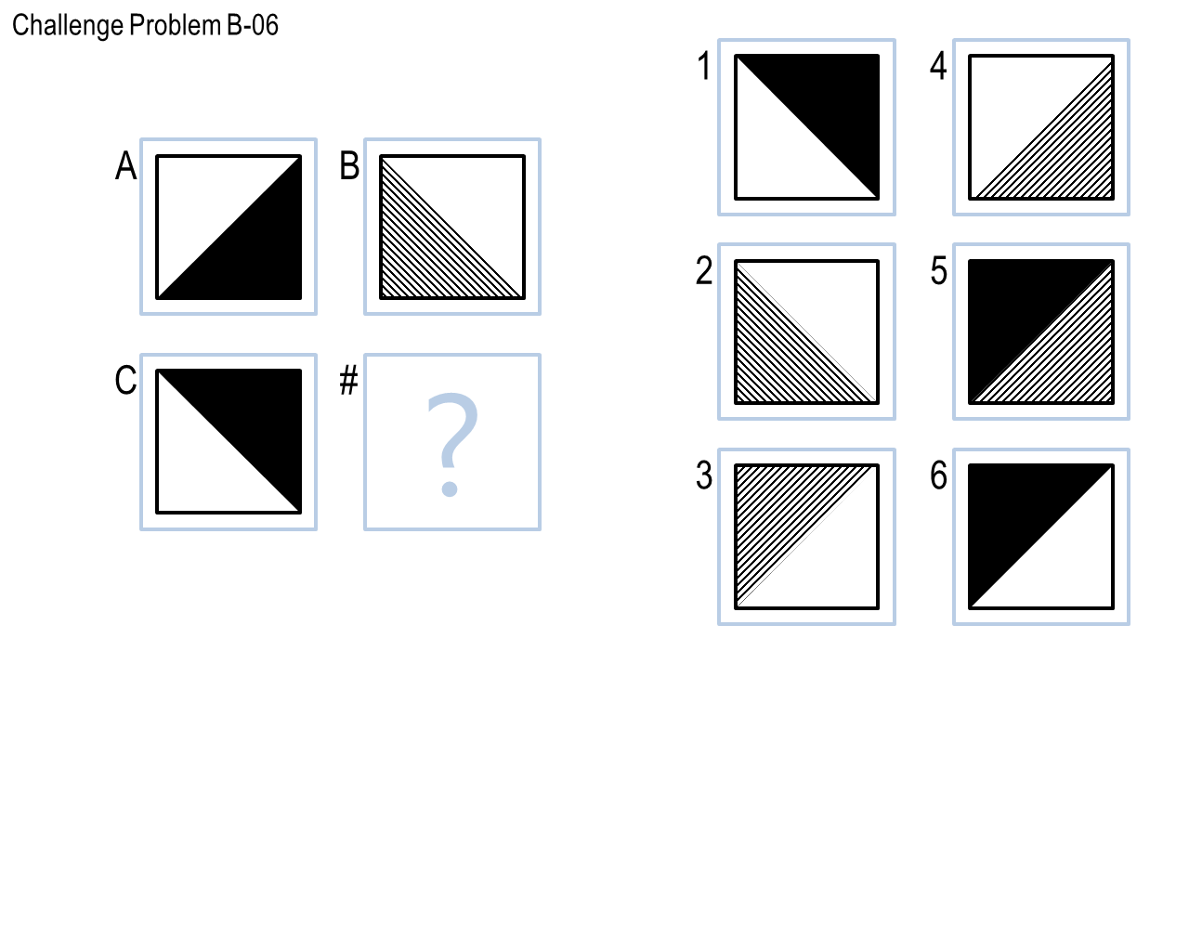
The agent performed relatively well on the basic and test problems, scoring 12/12 for the basic problems and 11/12 for the test problems, and 9/12 on the Raven’s problems. The design establishes a relatively accurate system to solve 2x2 Raven’s Progressive Matrices and performs extremely fast, answering all questions in about 5 seconds, but it certainly also has its limitations. The agent generally performs very well if the transformations involved could be solved by one of the seven transformations designed into the agent and if the images are aligned relatively perfectly pixel wise. For example, if frame B is frame A rotated by 90 degrees, then frame B should be the same as the picture of A rotated by 90 degrees pixel wise. If the images do not align within the root mean square difference set in the agent, then sometimes these pixel differences could throw the agent off and result in the incorrect answer being given or the problem being skipped. This has been discovered to be a key problem in solving the challenging problems that technically could be solved by the transformations defined, such as the reflection problems 6 and 7 in the challenging set, the textures and slight pixel differences involved in the problems hindered the agent’s ability to compare the images correctly. Therefore, under the circumstance where there are no pixel differences between the images, then the agent should perform much better than it does now. On the other hand, if these pixel differences are enhanced, such as shifting the shapes slightly in the frames will result in poorer performance. Taking a closer look at Challenge Problem B-06 as an example, one could see intuitively that frame C is frame A reflected on the X-Axis, and the agent is able to recognize this. With the transformation tested being successful, the agent attempts to reflect figure B and then attempts to compare the reflected image with the answer choices, the rotated image is shown below on the left and the correct answer choice 3 is shown on the right, one could now see that the images are different in the patterns that are drawn in the square, this throws the agent off when it calculates the RMSE to be out of the defined range and it skips the correct solution and returns -1 for this problem.
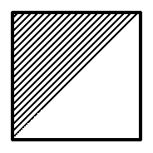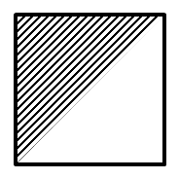
Furthermore, the agent performs more accurately with the transformation methods that do not involve pixel comparisons, which means excluding the transformations for pixel difference, pixel ratio as well as the and transformation. These three transformations involving comparing pixel differences or ratios in one way or another, therefore, if the solution list contains more than one solution with relatively the same number of black pixels as the correct solution or the same black pixels to total pixels ratio, this could result in the incorrect solution being chosen by the agent. As humans, intuitively we could recognize patterns that are similar but not exactly the same, such as the example shown above for Challenge Problem B-06. For AI agents, however, a slight disruption in the way the patterns are drawn could hinder the abilities of agents to solve problems. Therefore, for an AI agent to solve problem like these, perhaps a set of production rules could be implemented, where the agent will learn from its episodic memory when a pattern could not be recognized for a certain transformation that should generate a solution.
The concepts of KBAI have been used throughout the design and implementation of the agent. As discussed above, the reasoning process of the agent used the concepts of semantic networks and frames, as well as the problem-solving method of generate and test to identify the transformations between the reference images and the solution. As I continue to improve and expand the implementation of the agent, perhaps I will consider including the use of production rules into the agent for it to solve more complicated problems. To summarize, designing and implementing this agent has shown that it is extremely difficult for AI agents to replicate human behavior when it comes to solving RPM problems. I have discussed above how this agent shares some similarities to humans when it comes to reasoning and identifying the transformations in the problems, none the less, we as humans are able to recognize patterns at many levels, perhaps looking at the entire image, or a specific shape within an image. For this AI agent, implementing the granular comparison in terms of shapes proved to be extremely difficult, especially without the use of computer vision libraries. However, I did discover through this implementation that pixel comparisons are something that AI agents could use much more efficiently than humans and prove to be accurate in solving the problems in this set. This begs the question, as computer scientists, should we sometimes think like machines to implement better AI agents?

Works Cited
Goel, Ashok, and David Joyner. “Lesson 03 - Semantic Networks.” KBAI Ebook: Knowledge-Based Artificial Intelligence, Georgia Institute of Technology, 2016, pp. 28–42.
Goel, Ashok, and David Joyner. “Lesson 04 - Generate & Test.” KBAI Ebook: Knowledge-based Artificial Intelligence, Georgia Institute of Technology, 2016, pp. 43–52.
Goel, Ashok, and David Joyner. “Lesson 07 - Frames.” KBAI Ebook: Knowledge-based Artificial Intelligence, Georgia Institute of Technology, 2016, pp. 82–92.

